#E4 Greenhouse Mivi Density Expt - summer 2011

#ANALYSES

Experimental design:

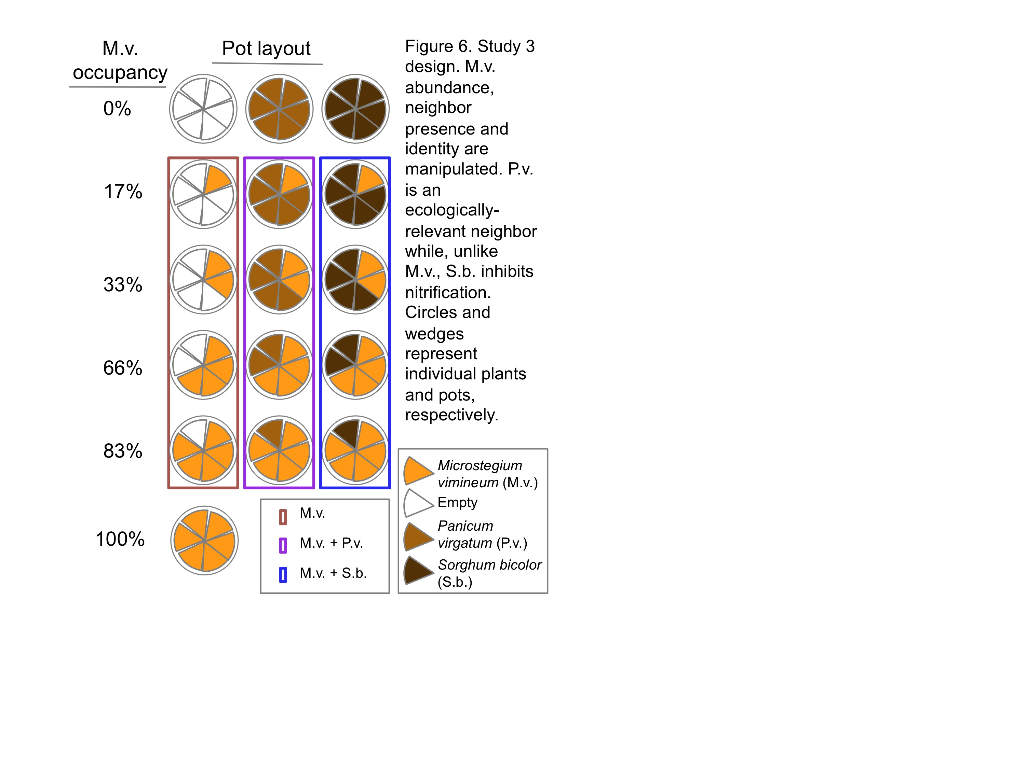

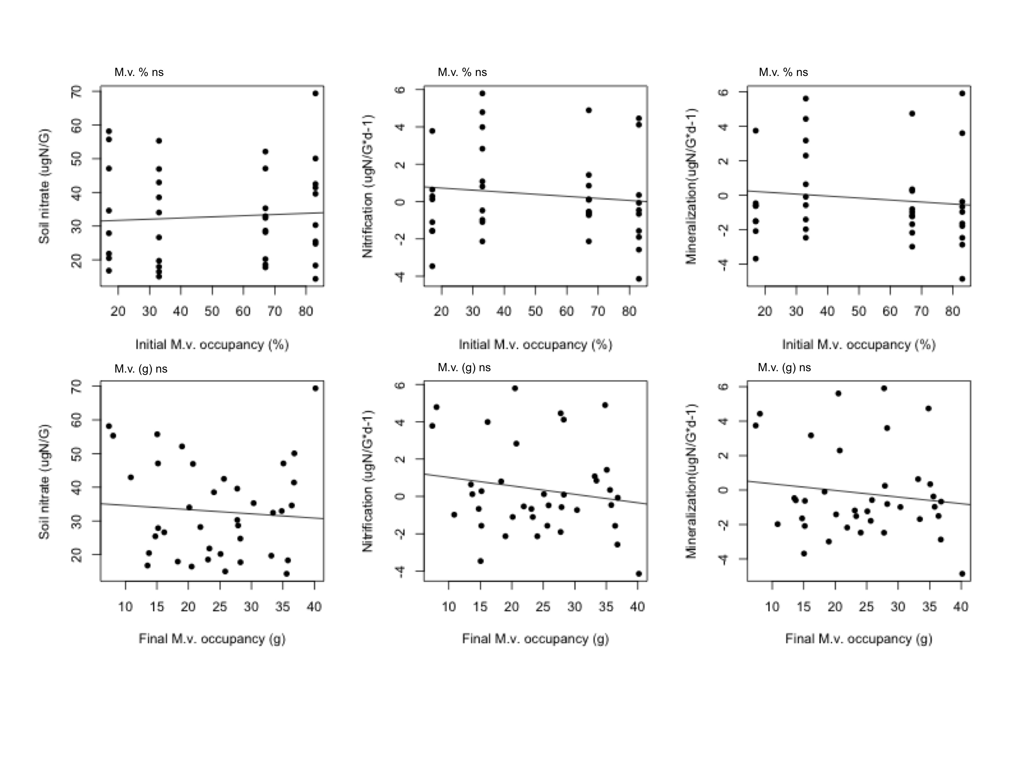

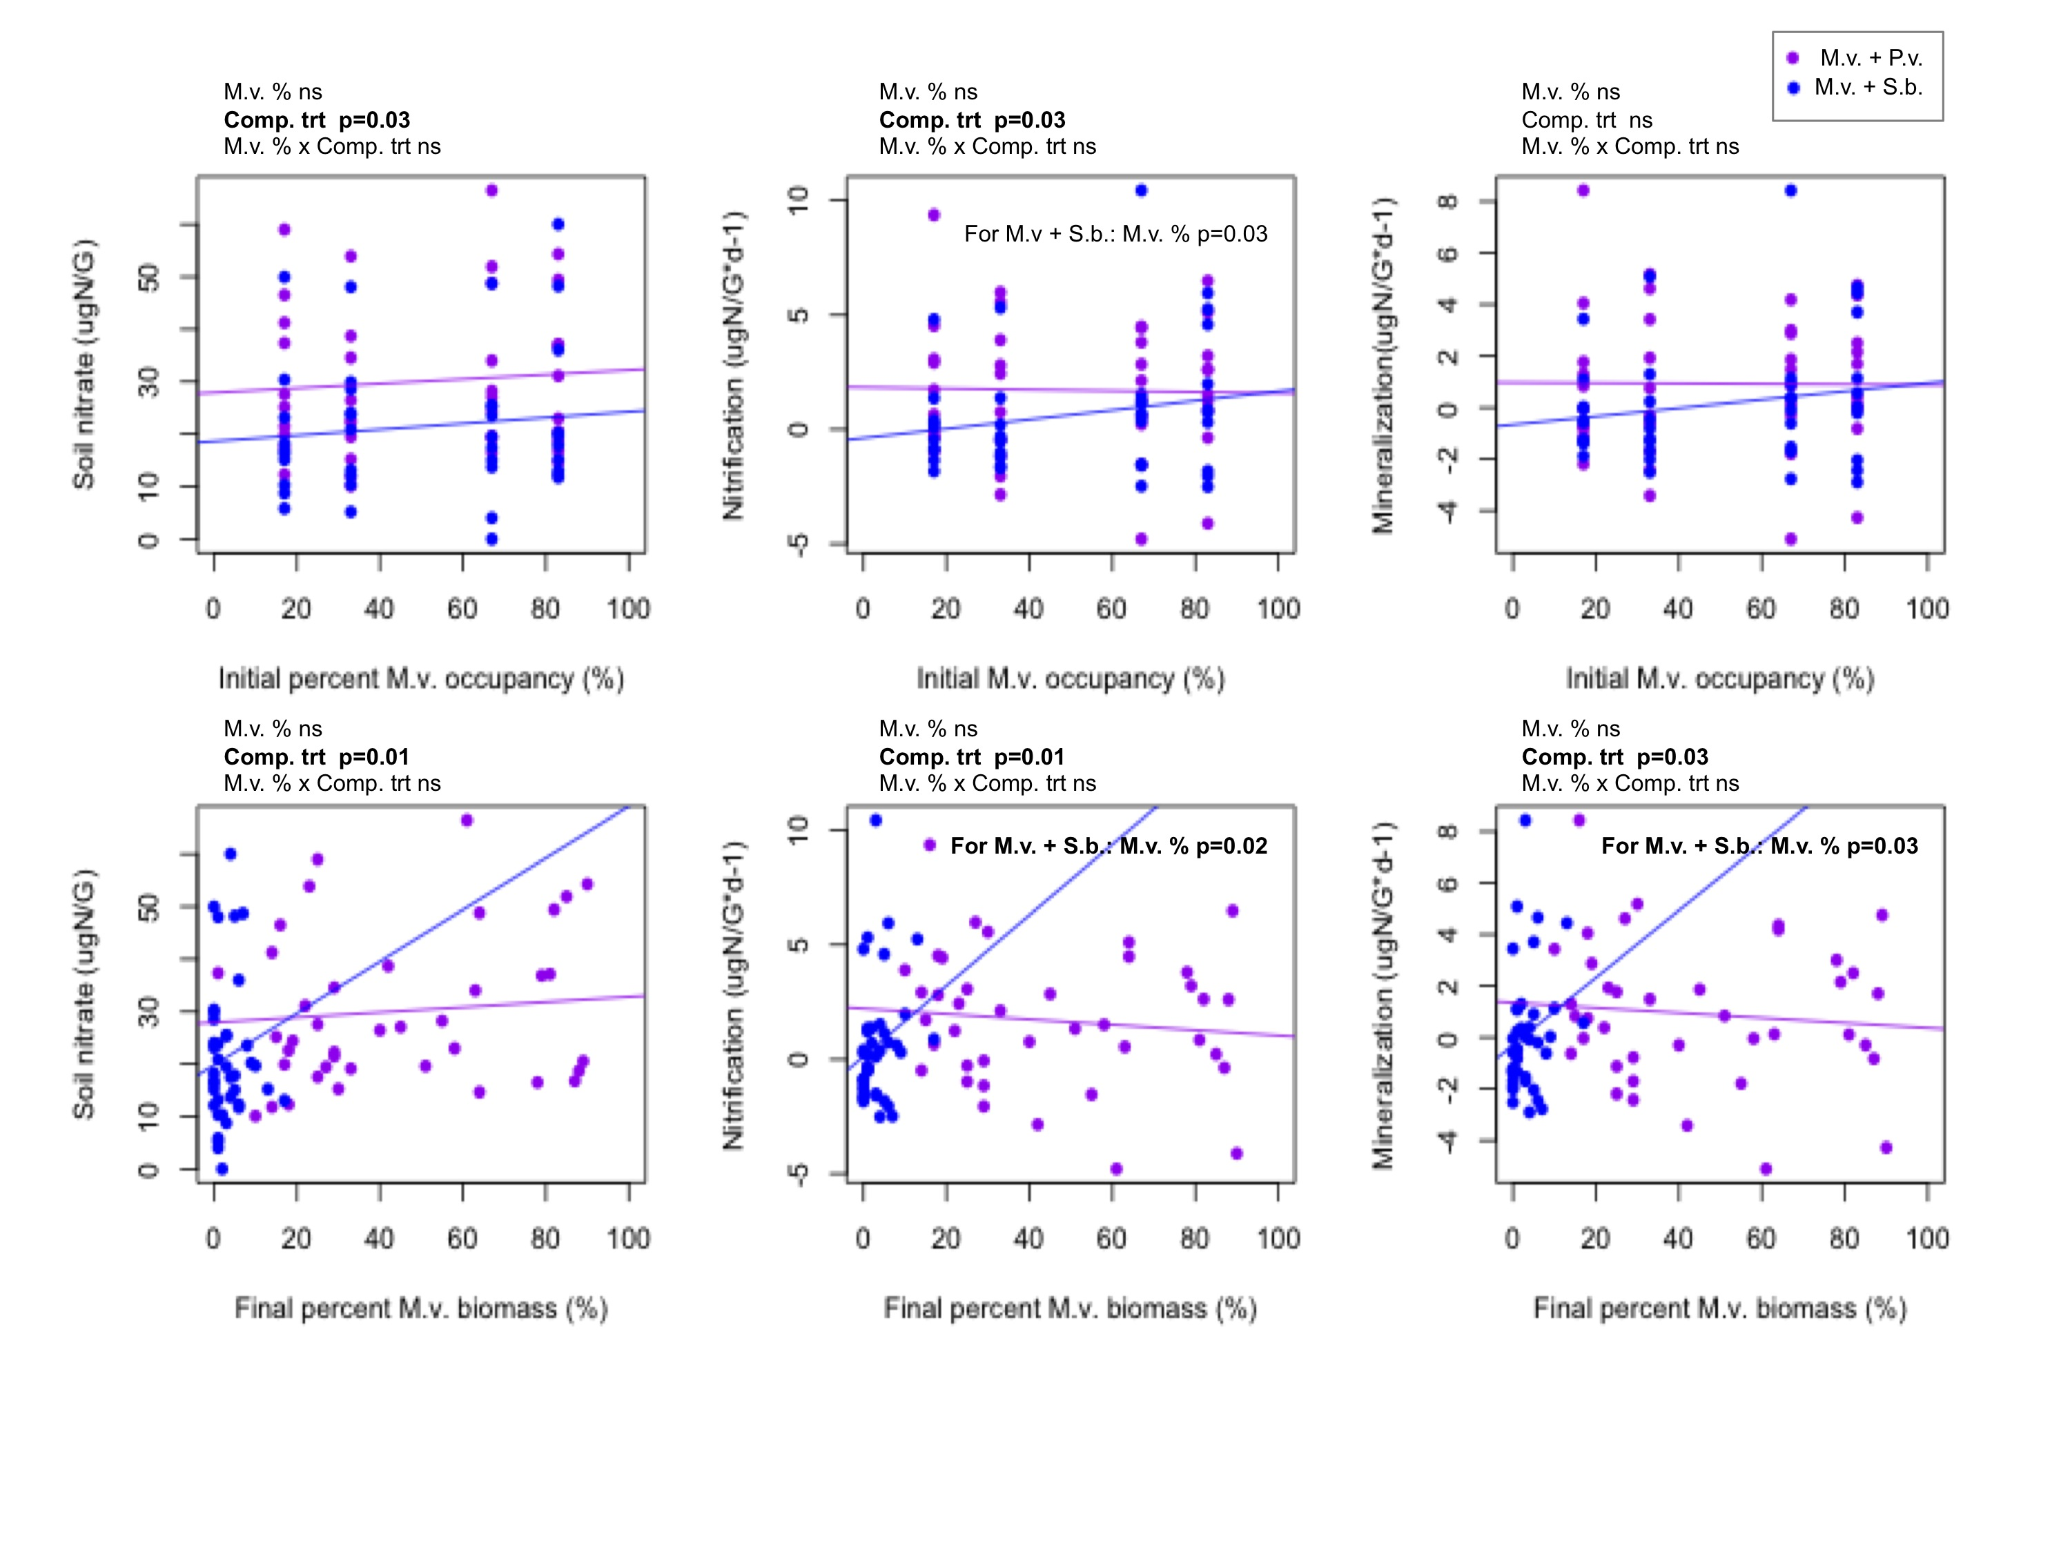

|  |  |  |  |  |  |  |  |  |  |  |  |  |  |  |  |
| --- | --- | --- | --- | --- | --- | --- | --- | --- | --- | --- | --- | --- | --- | --- | --- |
| ANOVA table 1 | | | | | | | | | | | | | | | |
| Dataset | Source of variation | Num d.f. | n | Initial percent M.v. occupancy | | | | | | Final percent M.v. biomass | | | | | |
| NO3- (ugN/G) | | Nitrif. potential (ugN/G*d-1) | | Minz. potential (ugN/G*d-1) | | NO3- (ugN/G) | | Nitrif. potential (ugN/G*d-1) | | Minz. potential (ugN/G*d-1) | |
| Coef | P | Coef | P | Coef | P | Coef | P | Coef | P | Coef | P |
| M.v. alone | M.v. (%) | 27 | 38 | 0.03 | 0.60 | -0.01 | 0.35 | -0.01 | 0.35 | -0.13 | 0.53 | -0.05 | 0.21 | -0.04 | 0.31 |
| M.v. + [P.v. or S.b.] | M.v. (%) | 67 | 80 | 0.04 | 0.40 | 0.00 | 0.84 | 0.00 | 0.93 | 0.04 | 0.45 | -0.01 | 0.27 | -0.01 | 0.32 |
| Comp. trt (S.b. vs P.v.) | 67 | 80 | -9.27 | **0.03** | -2.22 | **0.03** | -1.63 | 0.08 | -8.29 | **0.01** | -2.06 | **0.01** | -1.60 | **0.03** |
| M.v. (%) x Comp. trt S.b. | 67 | 80 | 0.01 | 0.85 | 0.02 | 0.20 | 0.02 | 0.30 | 0.38 | 0.29 | 0.13 | 0.14 | 0.11 | 0.19 |
| M.v. + P.v. | M.v. (%) | 29 | 40 | 0.04 | 0.48 | 0.00 | 0.85 | 0.00 | 0.94 | 0.05 | 0.44 | -0.01 | 0.38 | -0.01 | 0.43 |
| M.v. + S.b. | M.v. (%) | 29 | 40 | 0.06 | 0.20 | 0.02 | **0.03** | 0.02 | 0.06 | 0.49 | 0.11 | 0.15 | **0.02** | 0.13 | **0.03** |

|  |  |  |  |  |  |  |  |  |  |
| --- | --- | --- | --- | --- | --- | --- | --- | --- | --- |
| ANOVA table 2 | | | | | | | | | |
| Dataset | Source of variation | Num d.f. | n | NO3- (ugN/G) | | Nitrif. potential (ugN/G*d-1) | | Minz. potential (ugN/G*d-1) | |
| Coef | P | Coef | P | Coef | P |
| Empty + Mono- cultures | Mono. trt (M.v. vs None) | 27 | 40 | -41.06 | **0.00** | 1.45 | 0.23 | 2.59 | 0.08 |
| Mono. trt (P.v. vs None) | 27 | 40 | -52.71 | **0.00** | 0.58 | 0.62 | 0.91 | 0.53 |
| Mono. trt (S.b. vs None) | 27 | 40 | -64.06 | **0.00** | 0.28 | 0.81 | 0.94 | 0.51 |
| Mono- cultures | Mono. trt (P.v. vs M.v.) | 18 | 30 | -11.65 | **0.05** | -0.87 | 0.43 | -1.67 | 0.22 |
| Mono. trt (S.b. vs None) | 18 | 30 | -23.00 | **0.00** | -1.17 | 0.29 | -1.65 | 0.23 |

**R code=e4poster.R; uses: setwd("~/Desktop/E4_R"), all.txt**

#nitrification

#percmivibiom+comptrt+interactions

mod1<-lme(fixed=nitrifd~percmivibiom+comptrt+percmivibiom*comptrt, random=~1|bk, data=Comp, method="ML")

#investigate each species separately

mod1p<-lme(fixed=nitrifd~percmivibiom, random=~1|bk, data=CompPavi, method="ML")

mod1s<-lme(fixed=nitrifd~percmivibiom, random=~1|bk, data=CompSobi, method="ML")

#nitrate

#percmivibiom+comptrt+interactions

mod2<-lme(fixed=nodi~percmivibiom+comptrt+percmivibiom*comptrt, random=~1|bk, data=Comp, method="ML")

#investigate each species separately

mod2p<-lme(fixed=nodi~percmivibiom, random=~1|bk, data=CompPavi, method="ML")

mod2s<-lme(fixed=nodi~percmivibiom, random=~1|bk, data=CompSobi, method="ML")

#mineralization

#total+mivi+comptrt+interactions

mod3<-lme(fixed=minzd~percmivibiom+comptrt+percmivibiom*comptrt, random=~1|bk, data=Comp, method="ML")

#investigate each species separately

mod3p<-lme(fixed=minzd~percmivibiom, random=~1|bk, data=CompPavi, method="ML")

mod3s<-lme(fixed=minzd~percmivibiom, random=~1|bk, data=CompSobi, method="ML")

############################################################

#############################################################

#same tests, but use percent mivi occupancy

#nitrification

#percmiviind+comptrt+interactions

mod4<-lme(fixed=nitrifd~percmiviind+comptrt+percmiviind*comptrt, random=~1|bk, data=Comp, method="ML")

#investigate each species separately

mod4p<-lme(fixed=nitrifd~percmiviind, random=~1|bk, data=CompPavi, method="ML")

mod4s<-lme(fixed=nitrifd~percmiviind, random=~1|bk, data=CompSobi, method="ML")

#nitrate

#total+mivi+comptrt+interactions

mod5<-lme(fixed=nodi~percmiviind+comptrt+percmiviind*comptrt, random=~1|bk, data=Comp, method="ML")

#investigate each species separately

mod5p<-lme(fixed=nodi~percmiviind, random=~1|bk, data=CompPavi, method="ML")

mod5s<-lme(fixed=nodi~percmiviind, random=~1|bk, data=CompSobi, method="ML")

#mineralization

#total+mivi+comptrt+interactions

mod6<-lme(fixed=minzd~percmiviind+comptrt+percmiviind*comptrt, random=~1|bk, data=Comp, method="ML")

#investigate each species separately

mod6p<-lme(fixed=minzd~percmiviind, random=~1|bk, data=CompPavi, method="ML")

mod6s<-lme(fixed=minzd~percmiviind, random=~1|bk, data=CompSobi, method="ML")

############################################################

#############################################################

#same tests, but Mivi alone

#Mivi biomass

#nitrification

mod7n<-lme(fixed=nitrifd~mivi, random=~1|bk, data=CompEmpty, method="ML")

#nitrate

mod8n<-lme(fixed=nodi~mivi, random=~1|bk, data=CompEmpty, method="ML")

#mineralization

mod9n<-lme(fixed=minzd~mivi, random=~1|bk, data=CompEmpty, method="ML")

#Percent mivi occupancy

#nitrification

mod10n<-lme(fixed=nitrifd~percmiviind, random=~1|bk, data=CompEmpty, method="ML")

#nitrate

mod11n<-lme(fixed=nodi~percmiviind, random=~1|bk, data=CompEmpty, method="ML")

#mineralization

mod12n<-lme(fixed=minzd~percmiviind, random=~1|bk, data=CompEmpty, method="ML")

############################################################

#############################################################

#work with Monos, test plant trt

MonosE<-Monos[!(Monos$type=='Empty'),]

#nitrification

mod16<-lme(fixed=nitrifd~type, random=~1|bk, data=MonosE, method="ML")

#nitrate

mod17<-lme(fixed=nodi~type, random=~1|bk, data=MonosE, method="ML")

#mineralization

mod18<-lme(fixed=minzd~type, random=~1|bk, data=MonosE, method="ML")